Web Project
Learning Management System
Software Requirements
Team Members
ID | Name | Email
21038519 | Yara Hossam Elden Wahed | yarahossam97591@gmail.com
21047496 | Hania Hisham Ahmed | haniahisham4@gmail.com
21060177 | Nada Hossam Ahmed | nadahossamawad@gmail.com
21047445 | Nada Ahmed Ezzat | nadaahmed0100@gmail.com
21039956 | Abdelrahman Ahmed Abdelrahman | abdelrahmanahmed6335@gmail.com
21058818 | Ali Mohsen Abd El Monsef | ali.m.abdelmonsef@gmail.com
Group Code
CLS_GIZ3_SWD5_S1

Contents

Document Purpose and Audience 2
Introduction 3
Project Plane 4
Requirements 7
System Models 12

Document Purpose and Audience
Document Purpose
- The purpose of this document is to define the requirements and specifications for the Learning Management System (LMS). It provides a detailed description of the system’s features, functionalities, and constraints to ensure that all stakeholders have a common understanding of the project objectives.

Intended Audience
- This document is intended for the following stakeholders:
- Administrators (System Admins) – To understand management-related features and access control mechanisms.
- Instructors – To gain clarity on the tools available for course creation, delivery, and assessment.
- Students (End Users) – To be aware of the features available for learning, progress tracking, and certification.
- Guest – To browse and search courses with limited access and decide whether to register for full features.

Introduction

Software Purpose
The Learning Management System (LMS) is a web-based platform designed to facilitate online education by connecting students, instructors, and administrators in a structured environment. The system provides features such as course management, user enrollment, online assessments, performance tracking, notifications, and certification. It ensures a secure, scalable, and user-friendly solution for managing the complete learning lifecycle.
Objectives
- Provide an accessible platform for students to enroll in courses, access learning materials, and track their progress.
- Enable instructors to create and manage courses, assignments, and assessments efficiently.
- Offer administrators full control over user management, course approvals, and overall system monitoring.
- Enhance the learning experience with interactive tools such as quizzes, live lectures, notifications, and automated certificates.
By centralizing these functionalities, the LMS aims to improve learning outcomes, streamline course management, and enhance communication between all stakeholders.

Software Scope
The LMS will include the following functionalities:
- User Management: Registration, authentication, profile management, and role-based access (Admin, Instructor, Student, Guest).
- Course Management: Course creation, enrollment, lecture uploads, assignments, quizzes, and grading.
- Assessment & Grading: Online quizzes, assignment submissions, and feedback.
- Notification System: Alerts for deadlines, results, enrollments, and reminders via in-system and email notifications.
- Certificate Management: Auto-generated completion certificates in PDF format.
- Security & Access Control: Role-based permissions, secure authentication, data privacy, and session management.
- Non-Functional Features: Scalability, high performance, usability, mobile responsiveness, and integration with third-party tools (Zoom, Google Meet, payment gateways).

Project Plan

Timeline
Week | Tasks / Activities | Milestones | Deliverables | Resources
Week 1 | - Define project requirements - Initial research Draft project scope & objectives | Project Kick-off | Project proposal & scope document | Project Manager, Analyst
Week 2 | - Design wireframes & user journey - Database schema design - UI/UX initial design | Design Approval | Wireframes + UI draft | Designer, Developer
Week 3 | - Start core development (backend + frontend setup) - API integration (if needed) - Internal testing (basic) | Core System Ready | Functional prototype | Developers, QA
Week 4 | - Final testing & bug fixing - Documentation (user manual, tech doc) - Final presentation/demo | Project Closure | Final product + documentation | Full Team

Milestones
- M1 (End of Week 1): Requirements finalized & System design completed (ERD, UML diagrams, UI/UX wireframes).
- M2 (End of Week 2): Database ready + core LMS features implemented.
- M3 (End of Week 3): Core LMS features implemented (user management, course management, basic assessments).
- M4 (End of Week 4): Testing completed (>80% pass rate) + Final submission & presentation.

Deliverables

UML Diagrams (Use case, Class, Activity, Sequence, ERD)

Database Schema (Logical & Physical)

UI/UX Wireframes

Source Code + README

Test Plan & Bug Report

Final Report + Presentation

Resource Allocation by Week

Week 1–2 (Requirements & Design)

PM → Finalize requirements, risk assessment.

Backend Dev → Draft ERD + database schema.

Frontend/UI → Create wireframes & mockups.

Documentation Lead → Project proposal + requirements doc.

Tester → Prepare initial test plan.

Week 3 (Implementation – Core LMS Features)

Backend Dev → Implement user management + course management modules.

Frontend/UI → Build UI pages (login, dashboard, course view).

PM → Monitor progress, resolve blockers.

Tester → Start unit testing.

Documentation Lead → Update system design doc.

Week 4 (Testing & Final Delivery)

Backend Dev → Fix bugs, finalize features.

Frontend/UI → Polish UI + integrate backend.

Tester → Run test cases, document results.

PM → Ensure milestones met, prepare for presentation.

Documentation Lead → Compile final report + PPT.

Tools & Technologies

Development: Java/Spring Boot, MySQL, HTML/CSS/JS.

Design: Figma (UI/UX), Lucidchart/Draw.io (ERD/UML).

Collaboration: GitHub (version control), Google Drive (docs).

Testing: JUnit, manual test cases.

Requirements

User Management

User Types
- Admin (Super user, only one exists in the system)
- Instructor
- Student
- Guest

Admin Capabilities
- Approve or reject user registration applications.
- Create, update, and delete user accounts.
- Update personal admin account.
- Manage system-level entities (skills, categories, etc.).

Instructor Capabilities
- Cannot manage users.
- Request enrollment as an instructor in specific courses.
- Manage course-related content (assignments, tests, lectures).

Student Capabilities
- Cannot manage users.
- Focused only on enrolling, learning, and interacting with course content.

Guest Capabilities
- Can only browse and search courses.
- Must register to access advanced features.

Features
- User Registration & Login (with role-based access control).
- Profile Management (view/update personal information).
- Password recovery, email verification.
- Account activation/deactivation by admin.

Course Management

Admin Capabilities
- CRUD (Create, Read, Update, Delete) courses.
- Approve user enrollment in courses (instructors Only).
- Remove users from courses.
- Manage categories & skills (only admin can).
- Track course progress (all users).
- Upload recorded lectures (if needed).

Instructor Capabilities
- Request enrollment as instructor.
- Browse courses.
- Create & manage assignments and quizzes/tests.
- Launch live lectures/meetings.
- Upload recorded lectures.
- Upload lecture materials (slides, PDFs, docs).
- Grade assignments and quizzes.

Student Capabilities
- Enroll in courses (with admin approval if required).
- Browse courses.
- View course details.
- Watch Recorded lecture videos.
- Join Live Lectures.
- Download lecture materials.
- Take quizzes/tests.
- Submit assignments.
- Track personal progress.
- View grades.
- Download certificates of completion.
- Rate and review courses.

Guest Capabilities
- Browse courses.
- Search courses by category, skill, or keyword.
- Register to gain more access.

3. Assessment & Grading

Assessment Types
- Quizzes (MCQ, T/F, short answers)
- Assignments (File upload / text submission)

Quiz Management
- Instructors can create quizzes per course.
- Questions bank maintained per course.
- Randomized questions for each student attempt.
- Auto-grading for MCQ & T/F.
- Manual grading for short answers.

Assignment Management
- Students can upload files as submissions.
- Instructors review & grade manually.
- Plagiarism check (optional future feature).

Feedback
- Automated Feedback (for quizzes – grades, wrong answers, correct answers).
- Manual Feedback (for assignments – instructor comments, grade).

4. Performance Tracking
- Student Progress Tracking:
  - Scores (quizzes, assignments).
  - Attendance in live lectures.
  - Course completion status.
- Instructor Tracking:
  - Student performance reports.
  - Participation statistics.
- Admin Tracking:
  - Overall course performance.
  - Instructor activity reports.

5. Notification System
- For Students:
  - Enrollment confirmation.
  - Assignment grading results.
  - Quiz results (automated).
  - Upcoming deadlines/reminders.
- For Instructors:
  - New student enrollments.
  - Assignment submissions waiting for grading.
  - Course-related system alerts.
- Features:
  - Separate “Unread” vs “All” notifications.
  - Email notifications in addition to in-system alerts.

6. Certificate Management
- Certificates generated automatically after course completion.
- Includes student name, course name, completion date, and instructor/admin signature.
- Downloadable in PDF format.
- Stored in student’s profile for future access.

7. Course Review & Rating
- Students can rate courses (e.g., 1–5 stars).
- Students can submit written reviews.
- Instructors and Admins can view course feedback.
- Admin moderates inappropriate reviews.

8. Security & Access Control
- Authentication:
  - Implemented via Spring Security (if using Java/Spring).
  - Passwords hashed & stored securely.
- Authorization:
  - Role-based access control (RBAC).
  - Permissions based strictly on user type (Admin, Instructor, Student, Guest).
- Session Management:
  - Secure login sessions.
  - Automatic logout after inactivity.
- Data Privacy:
  - User information secured and GDPR-compliant (if required).

Non Functional Requirements

Requirement | Details
Performance | - Should support hundreds/thousands of concurrent users.  - Optimized DB queries for fast search & reporting.
Scalability | - Should allow easy integration of new roles/features.  - Support for cloud storage (lectures, materials, backups).
Usability | - Mobile-friendly (responsive UI).  - Easy navigation, accessibility (WCAG compliance).
Reliability | - Regular data backup and restore mechanisms.  - 99.9% uptime with hosting/cloud solutions.
Integration | - Support for integration with video conferencing tools (Zoom, MS Teams, Google Meet).  - Payment gateway integration (if monetized).

System Models

Use Case Model
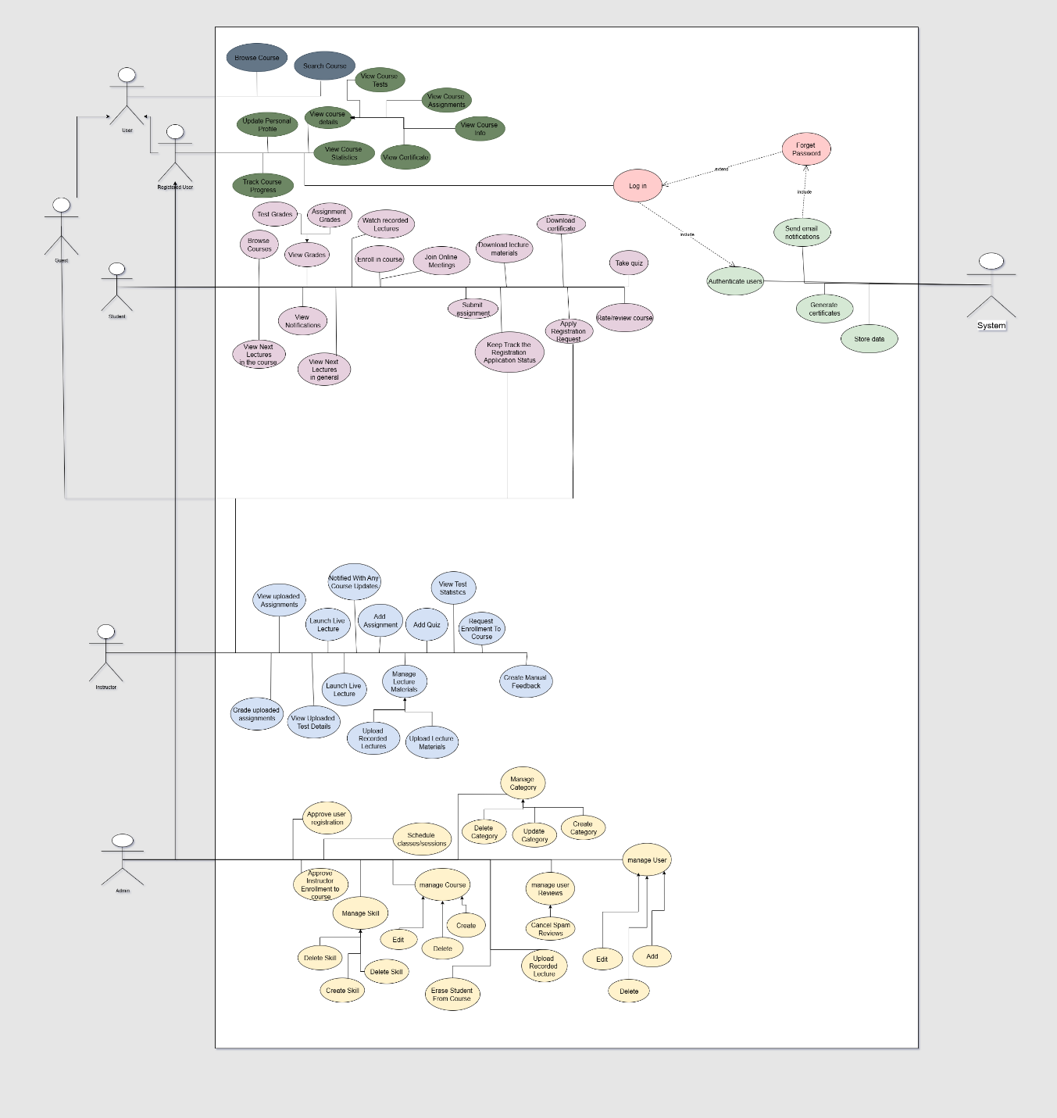

Use Case Tables
Use Case ID:
Use Case Name: | Create Assignment
Actors: | Instructor
Pre-conditions: | The instructor should be logged in.  The Email should have the instructor role.
Post-conditions: | The assignment is uploaded and viewable by students.
Flow of events: | User Action | System Action
 | 1- The instructor goes to create assignment page
 |  | 2- The system verifies authorization. and show the create page
 | 3- The instructor chooses the assignment file and uploads the file.
 |  | 4- system shows that the file uploaded and show the ability to remove the uploaded file
 | 5- The instructor presses the submit button.
 |  | 6- The system shows that the assignment file is submitted.
Exceptions: | User Action | System Action
 | 1- The instructor chooses the file.
 |  | 2- The file is not with the PDF extension.
 |  | 3- The system rejects the submission and shows the user the reason.
Includes: | No use cases included.

Use Case ID:
Use Case Name: | Create Quiz
Actors: | Instructor
Pre-conditions: | The instructor should be logged in.  The email should have the instructor role.
Post-conditions: | The quiz is uploaded and viewable by students.
Flow of events: | User Action | System Action
 | 1- The instructor goes to create quiz page
 |  | 2- The system verifies authorization. and show the create page
 | 3- The instructor enters the number of questions that should be in the quiz, the duration of the quiz, and the start date and time of the quiz.
 | 4- The instructor creates a quiz.
 |  | 5- The system chooses random questions from the question bank of the course.
 |  | 6- The system shows that the quiz is ready and will start on Date.
Exceptions: | User Action | System Action
 | 1- The instructor chooses the file.
 |  | 2- The file is not with the PDF extension.
 |  | 3- The system rejects the submission and shows the user the reason.
Includes: | No use cases included.

Use Case ID:
Use Case Name: | Register
Actors: | Guest User (unregistered)
Pre-conditions: | The user has not registered before or is not logged in
Post-conditions: | A user account is created in the system
Flow of events: | User Action | System Action
 | 1-Guest user clicks on "Register" or "Sign Up" button
 |  | 2- System displays registration form with required fields
 | 3- Guest fills in registration details
 |  | 4- System validates input fields
 | 5- Guest clicks "Submit" or "Create Account" button
 |  | 7- The system checks if the email already exists in the database.
 |  | 8- system creates new user account
 |  | 9- System displays pending confirmation account message and send application to admin dashboard
 | 10-admin approve/decline user application
 |  | 11-system sends notification to user
Exceptions: | User Action | System Action
 | 1- User enters invalid email format
 |  | 2- system displays an error message.
 | 3- User enters password that doesn't meet requirements
 |  | 4- System displays error message "Password must be at least 8 characters with uppercase, lowercase, and numbers."
 | 5- User enters email that already exists
 |  | 6- System displays error message "This email is already registered. Please log in or use forgot password"
 | 7- User leaves required fields empty
 |  | 8- System displays error message "Please fill in all required fields."
 | 9- User's password and confirm password don't match
 |  | 10- System displays error message "Passwords do not match"
Includes: | - Email validation  - Password encryption  - Send confirmation email
Notes and Issues:

Use Case ID:
Use Case Name: | student joins the course
Actors: | Student
Pre-conditions: | Students should be logged in.  The email should have the student role.
Post-conditions: | Student join to course
Flow of events: | User Action | System Action
 | 1- Student requests course page
 |  | 2- The system shows the page that contain all of the active courses
 | 3- student write string to search courses
 |  | 4- System filters courses based on the word
 | 5- The student chooses a course to get its details.
 |  | 6- system show the course details
 | 7- Student applies to course
 |  | 8- System verification of overlapping
 | 9- Student joins the course
Exceptions: | User Action | System Action
 | 1- Student requests course details
 |  | 2- system shows course details
 | 3- The student requests to join the course.
 |  | 4- The system finds out that the student has overlapping courses.
 |  | 5- The system rejects the user request.
Includes: | Log in

Use Case ID:
Use Case Name: | Instructor applies for courses
Actors: | Instructor, Admin
Pre-conditions: | Instructors should be logged in.  The email should have the instructor role.
Post-conditions: | Instructors join the course
Flow of events: | User Action | System Action
 | 1- Instructors get courses page
 |  | 2- The system shows the courses page
 | 3- Instructors write strings to search courses.
 |  | 4- System filters courses based on the word.
 | 5- Instructors choose a course to get its details.
 |  | 6- system show the course details
 | 7- Instructor applies to course
 |  | 8- System verification of overlapping
 |  | 9- The system sends the application to the admin.
 | 10- Admin request applications page
 |  | 11- System Show Applications Page
 | 12- Admin request to see application details.
 |  | 13- The system shows application details.
 | 14- Admin Approve application
 |  | 16- System Send Notification to Instructor
Exceptions: | User Action | System Action
 | 1- Admin View Application Details
 |  | 2- system shows Application details
 | 3- Admin Deny Application
 |  | 4- System Send Notification to Instructor
Includes: | Log in

Use Case ID:
Use Case Name: | Lecture Establishment
Actors: | Instructor
Pre-conditions: | Instructors should be logged in.  The email should have the instructor role.
Post-conditions: | Instructors join to course
Flow of events: | User Action | System Action
 | 1- Instructor goes to the lecture page.
 |  | 2- The system shows the Lecture Page
 | 3- instructor creates Zoom Meeting and uploads the invitation link
 |  | 4- system sends to all students join to this course an email a lecture has started
Includes: | Log in

Use Case ID:
Use Case Name: | Course Creation
Actors: | Admin
Pre-conditions: | Admin should be logged in.  The email should have the admin role.
Post-conditions: | Course Created successfully
Flow of events: | User Action | System Action
 | 1- Admin goes to the course creation page.
 |  | 2- The system shows the Course Creation Page
 | 3- Admin fills requirements and press submit
 |  | 4- system check requirements and add the course to courses
Exceptions: | User Action | System Action
 | 1- Admin upload course requirement
 |  | 2- system check requirements
 |  | 3- system finds out that requirements are in wrong format
 |  | 5- The system rejects the admin request and shows an error message.
Includes: | Log in

Sequence Diagrams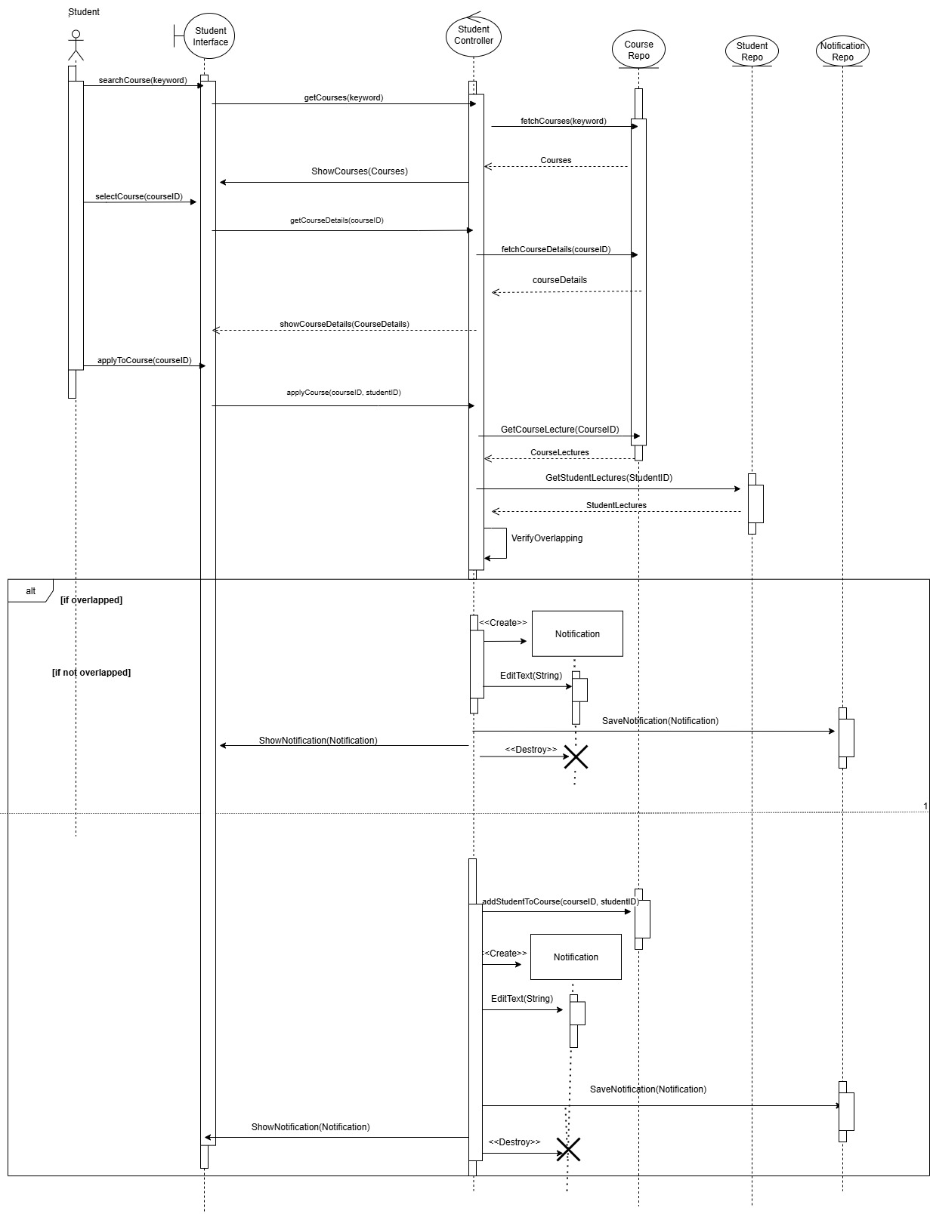
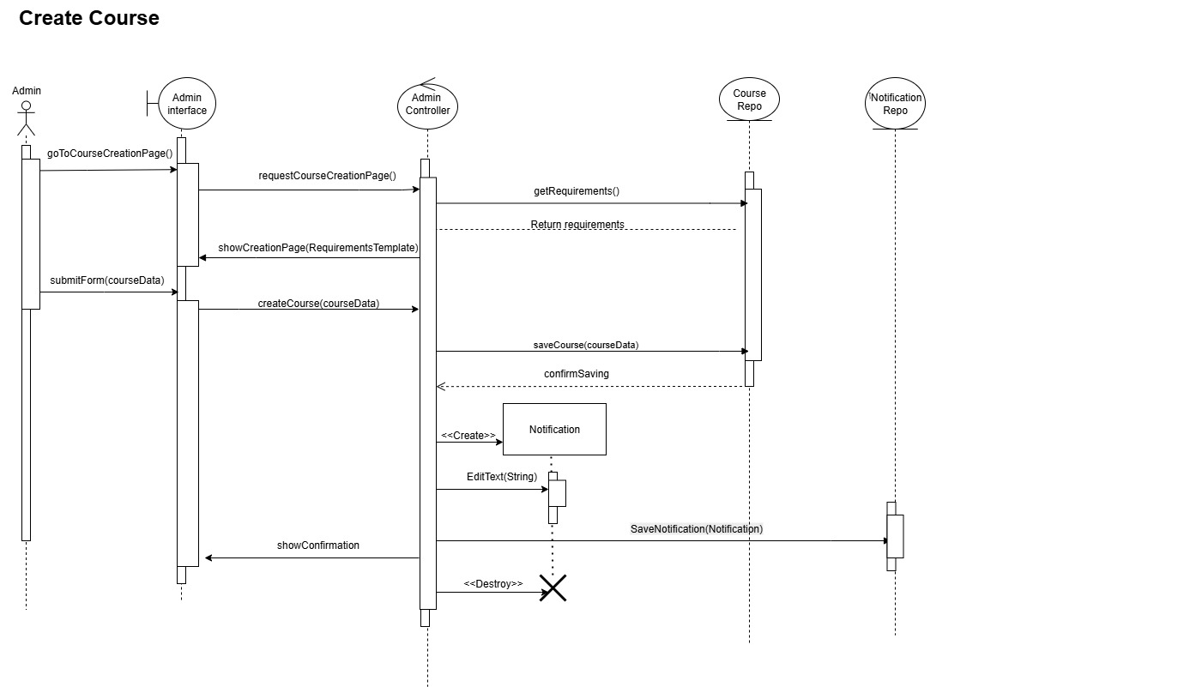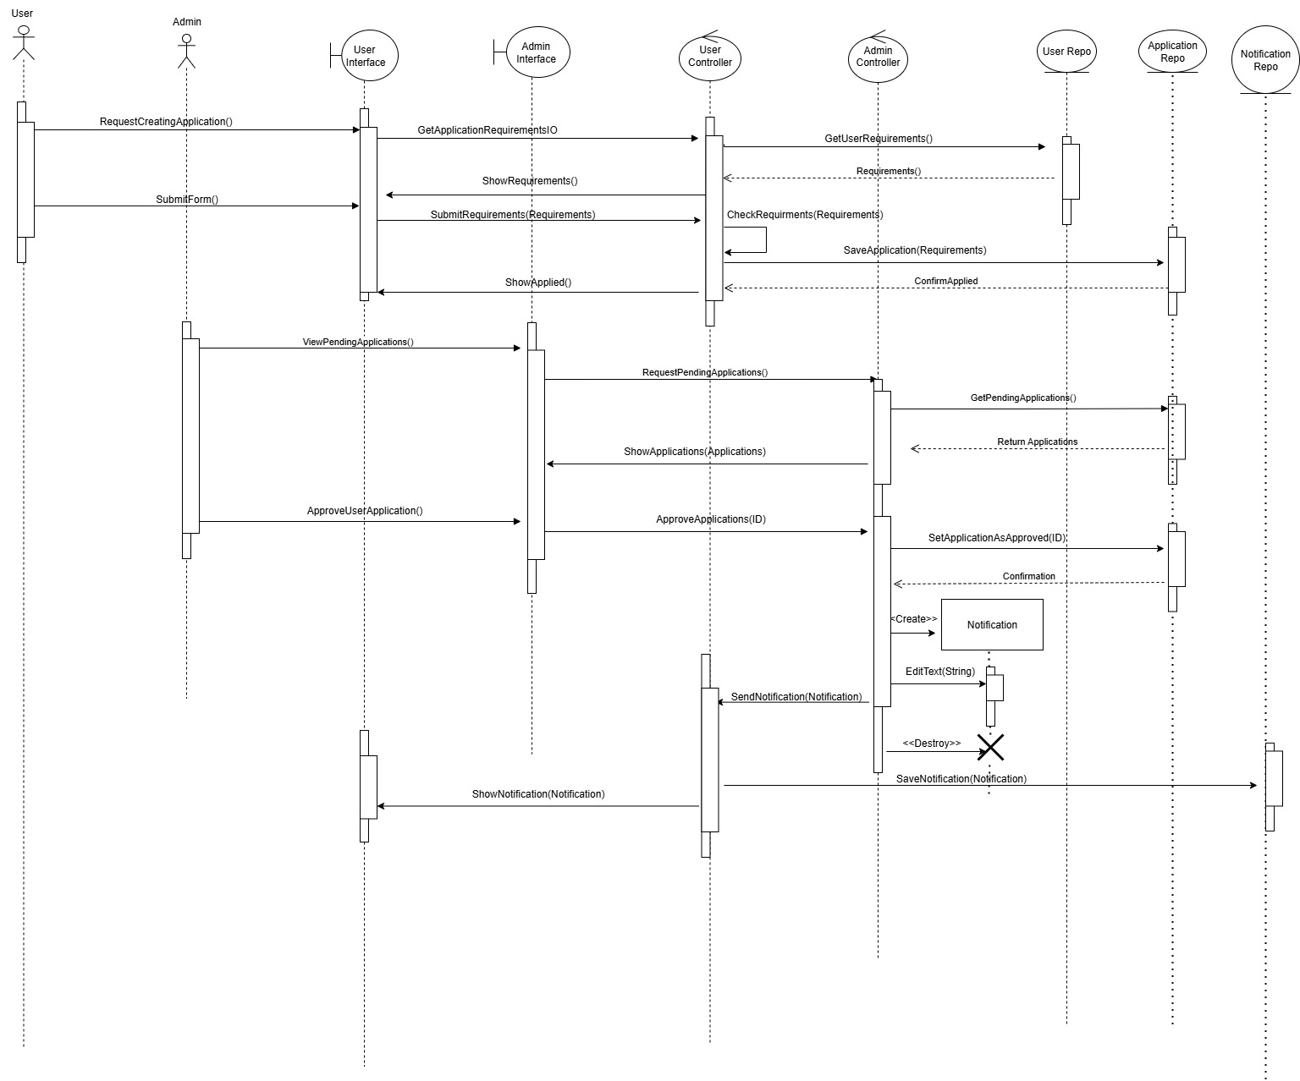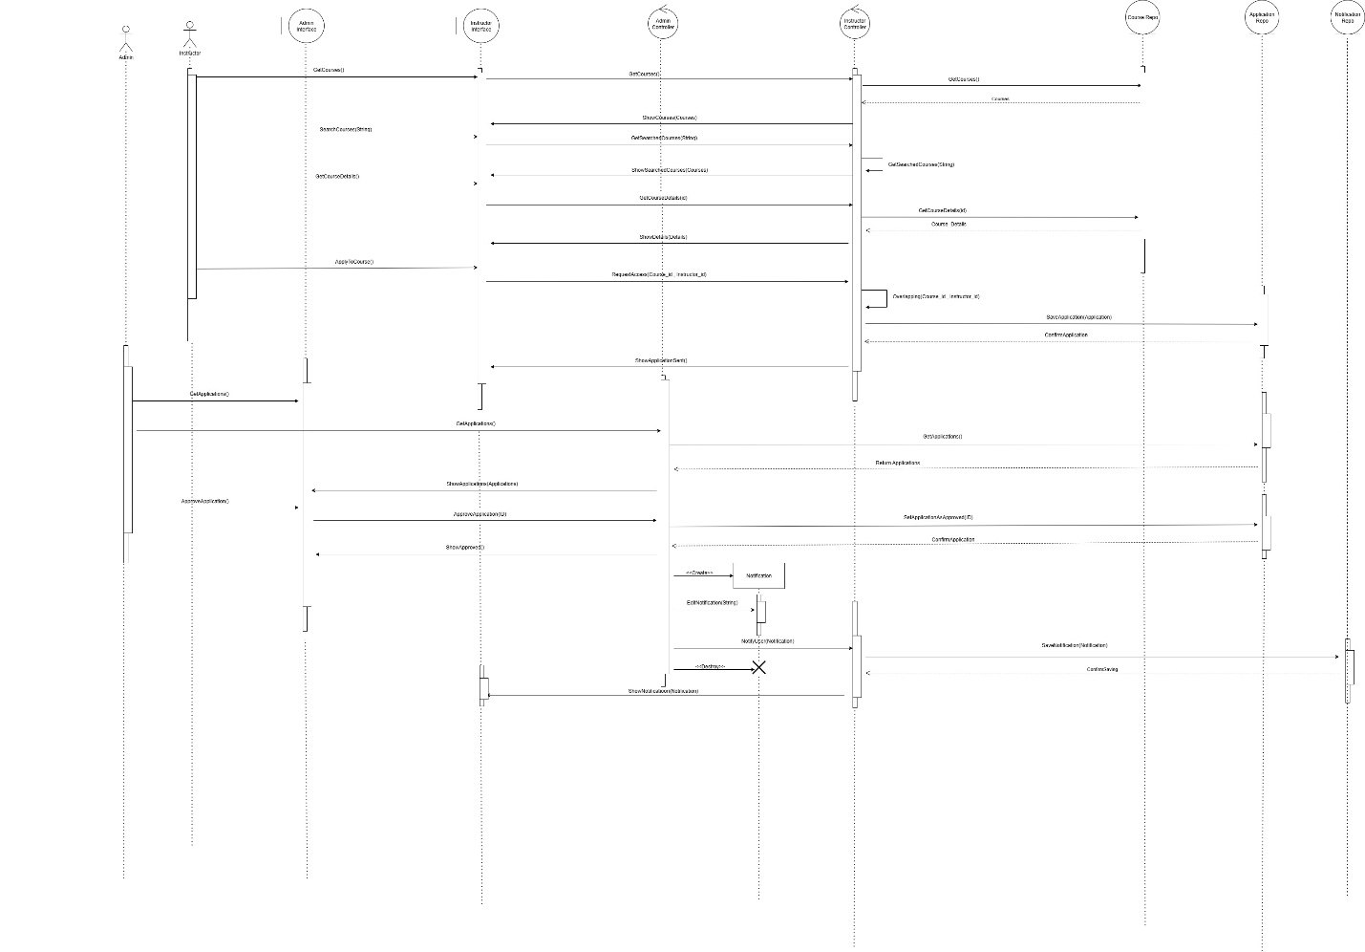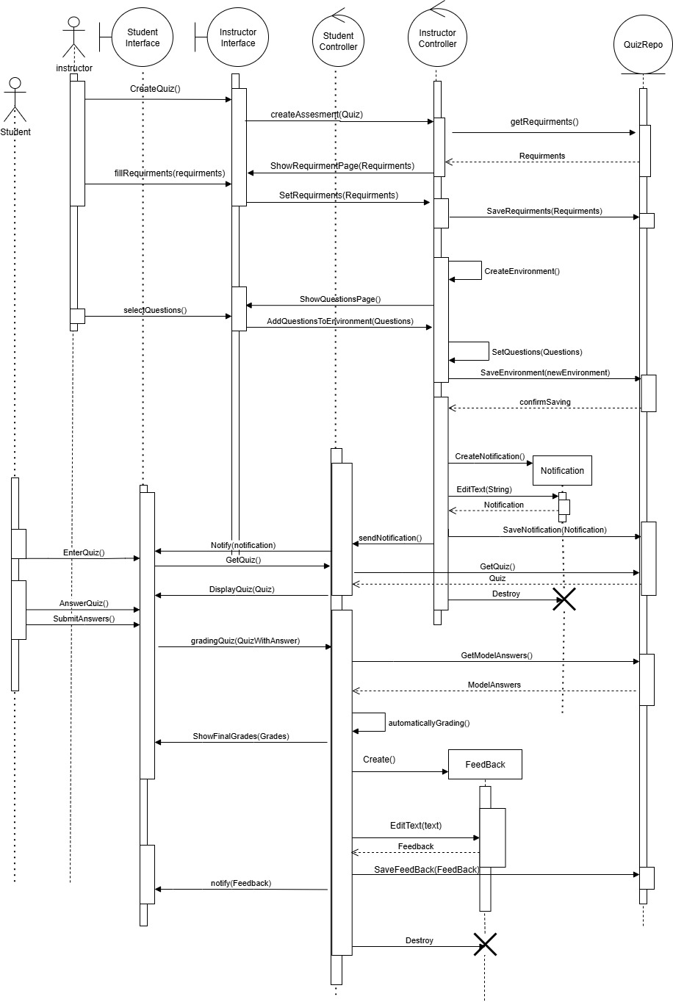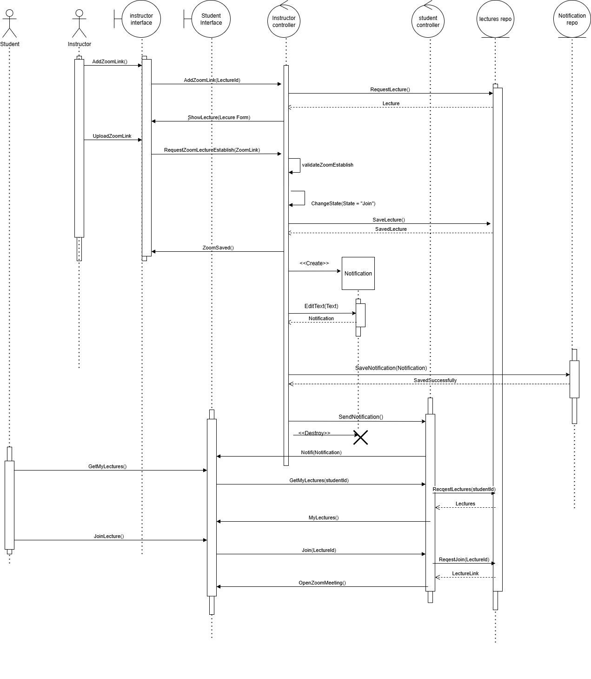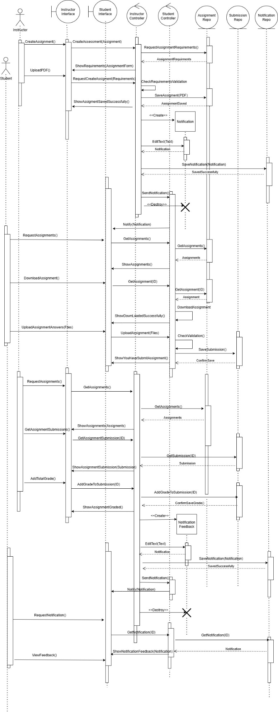
Class Diagram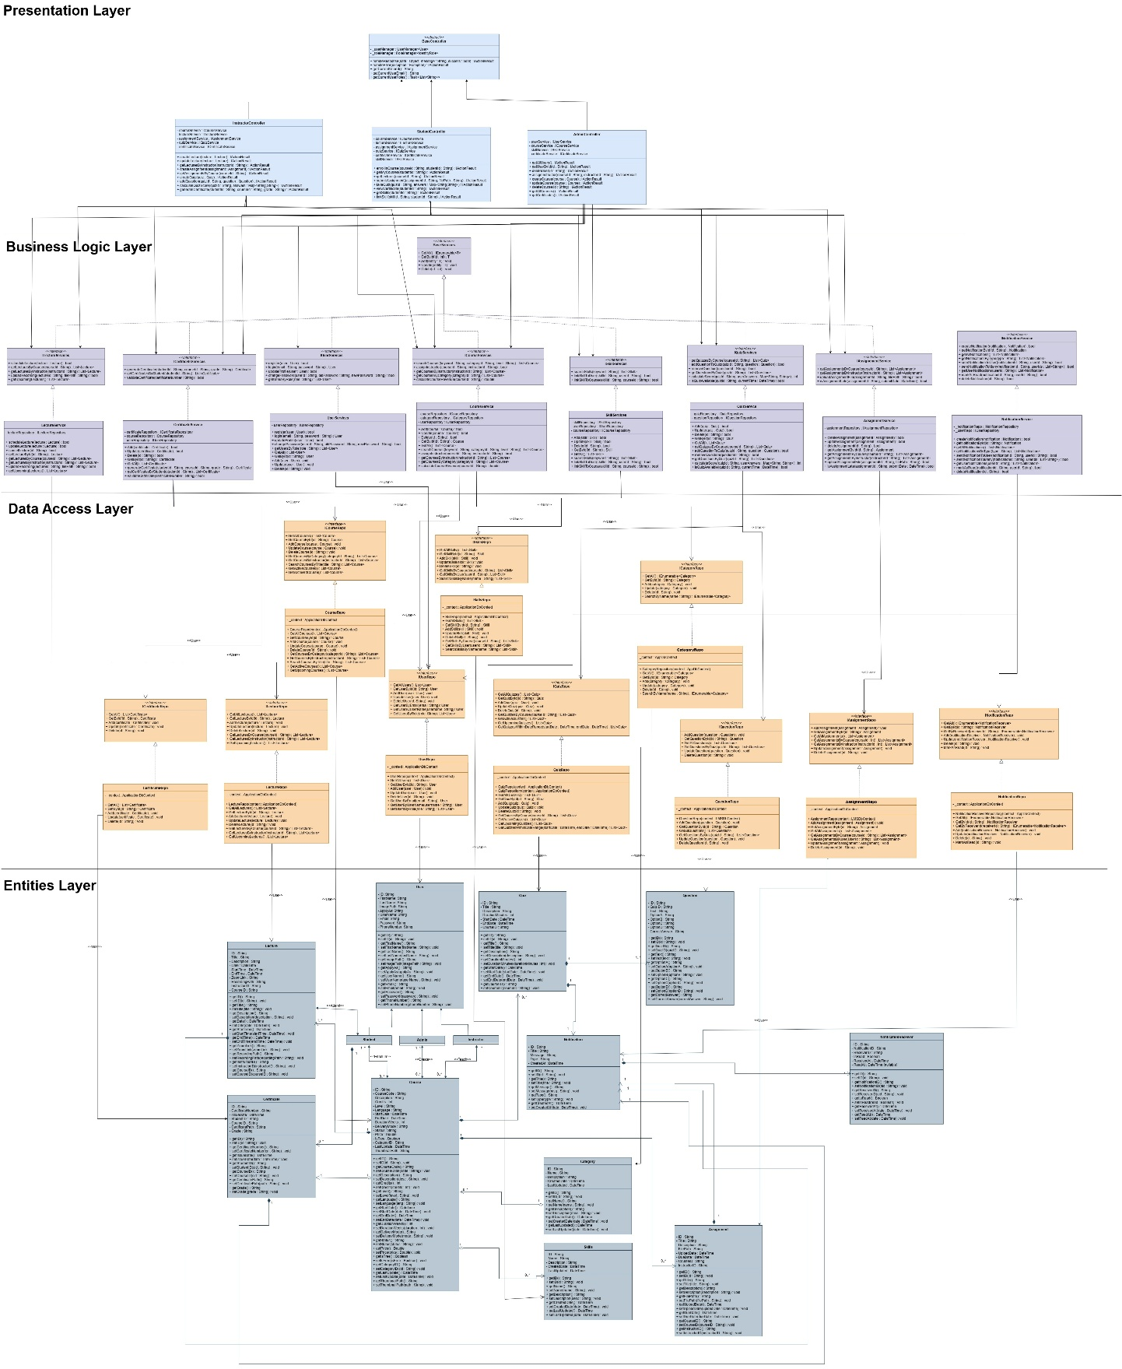

ERD
